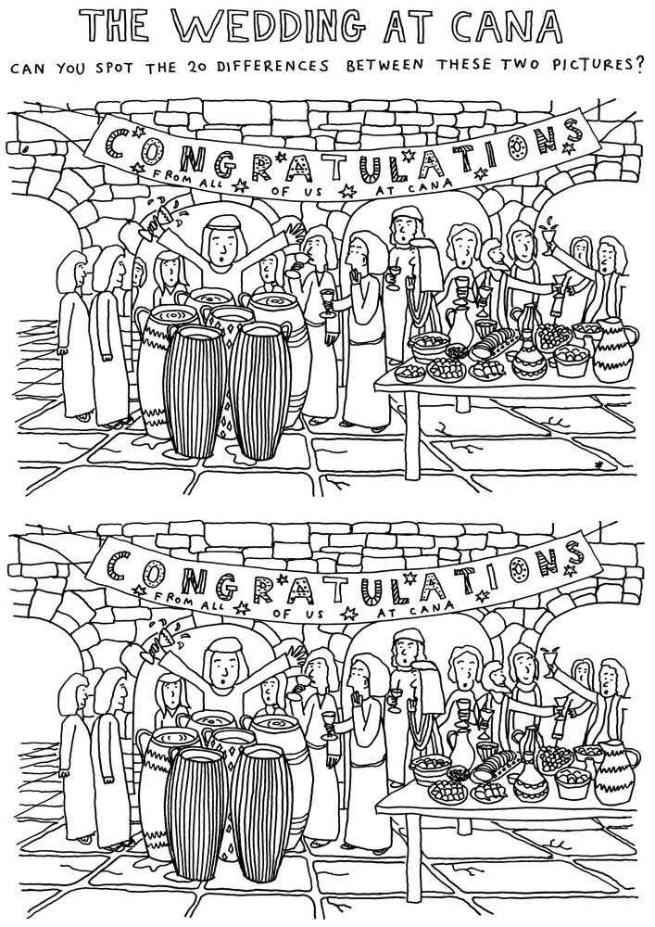

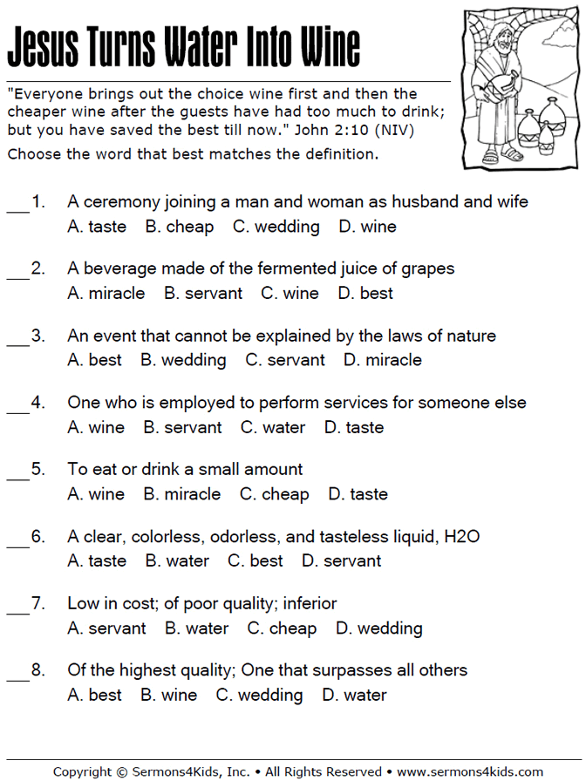

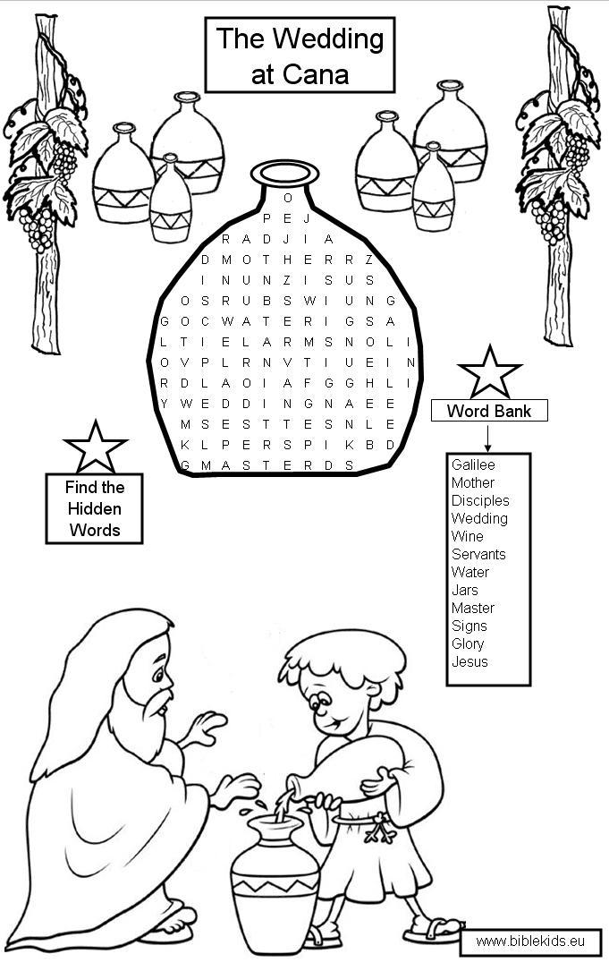
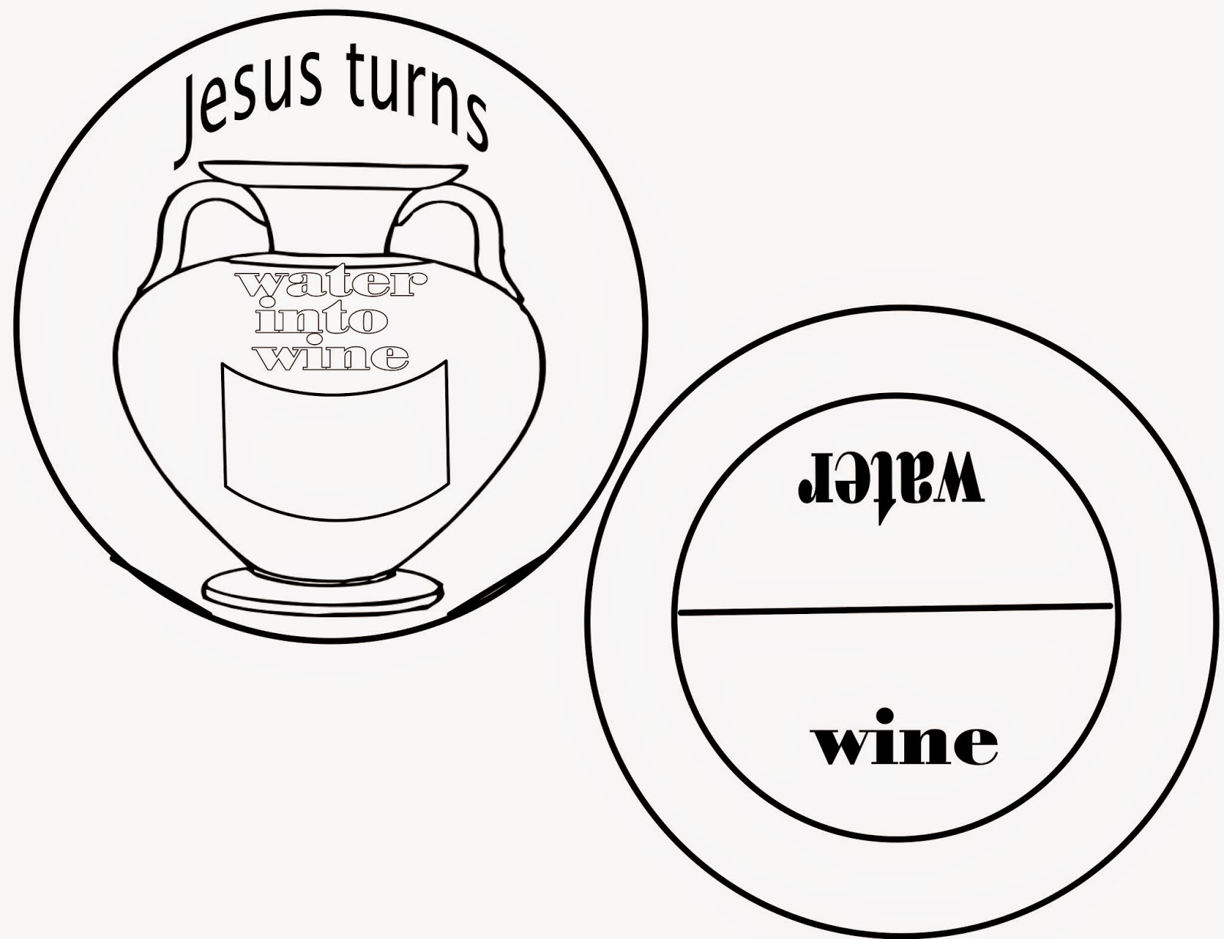
Hopefully you can download this picture onto your computer and place it on your own desktop publisher software and stretch it out to fill a page. Print on card stock and cut out. Cut out the insert on the circle with the jar so that when the pages are twisted, you show how Jesus turned water into wine. Cut a small section at the edge of the top circle so you can turn the bottom circle. Water is blue... Wine is red or purple...
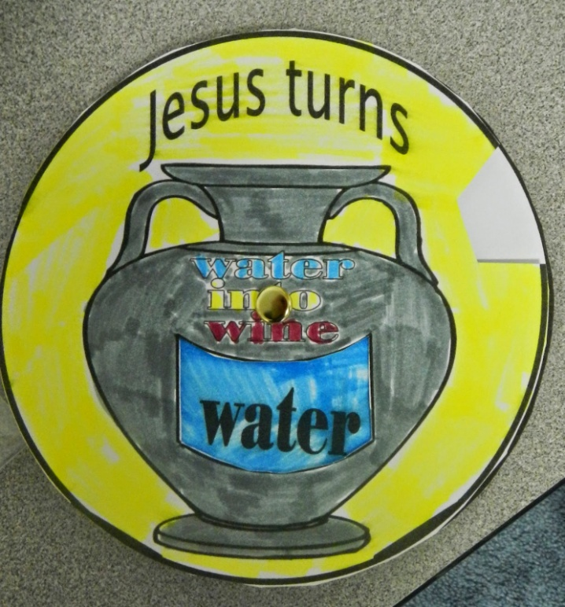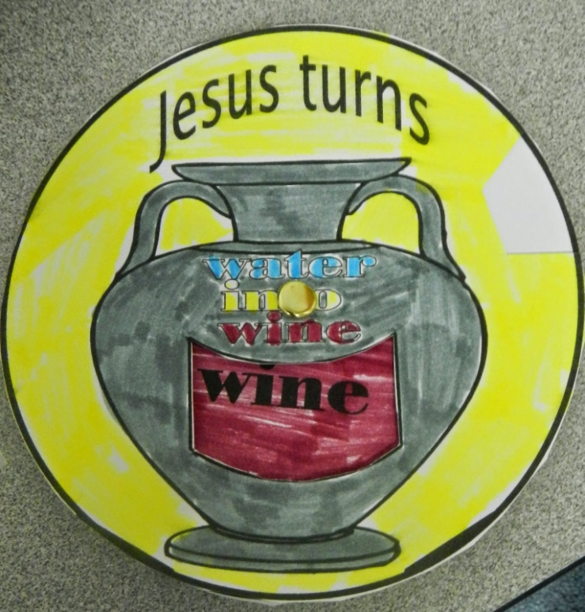
http://sundayschoolfun.blogspot.com/2015/02/the-first-miracle-jesus-turns-water.html?m=1

